Homework – Fundamentals & Applications

1. Define “Hydrodynamic Focusing” in your own words.
Hydrodynamic focusing is the process used in a flow cytometer to arrange cells into a narrow, single-file stream so that individual cells pass through the laser beam one at a time. The sample containing the cells is introduced into the center of a faster-flowing sheath fluid. The sheath fluid compresses and focuses the sample stream, producing a stable sample core under appropriate laminar-flow conditions. This allows the instrument to measure the light-scattering and fluorescence properties of individual cells accurately.
In simple terms: Sheath fluid → compresses sample stream → cells become aligned in single file → one cell at a time reaches the interrogation point.

2. Sketch a hypothetical FSC vs. SSC Plot.
FSC (X-axis) provides an estimate related to particle size/volume, while SSC (Y-axis) provides information about relative structural complexity or granularity.
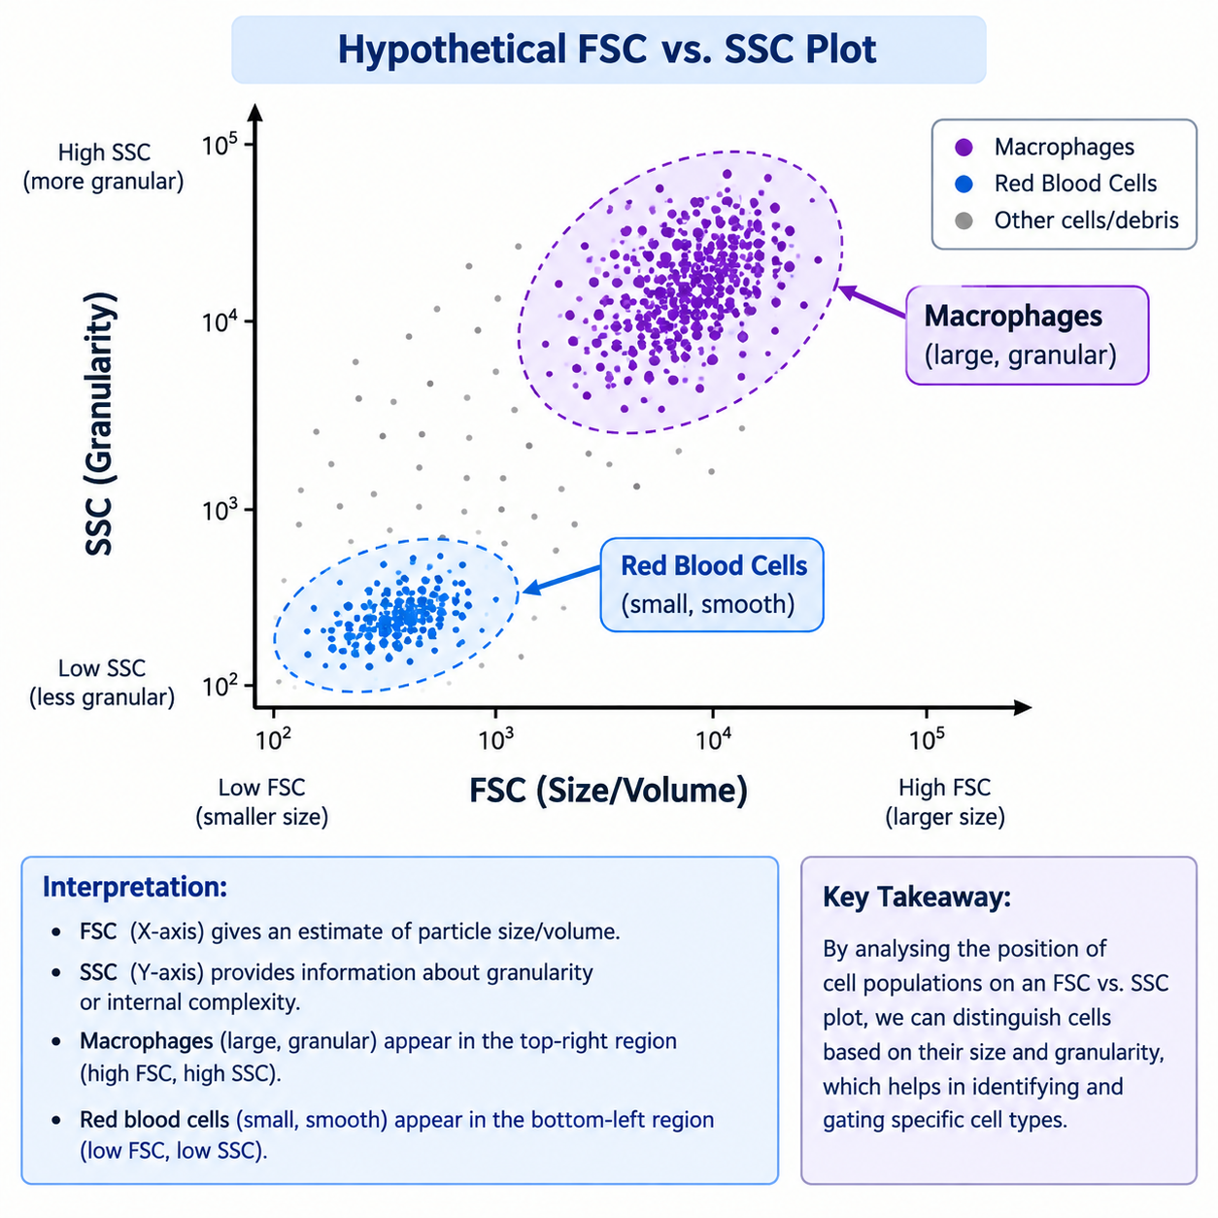
Figure 1. Hypothetical FSC vs. SSC plot showing the expected locations of the two populations.

Expected placement: Macrophages are placed toward the higher-FSC and higher-SSC region because they are relatively large and granular. Red blood cells are placed toward the lower-FSC and lower-SSC region in the simplified comparison because they are smaller and relatively less granular/smooth.

3. The Spectrophotometry Connection
Flow cytometry is closely connected to the same fundamental physics of light used in spectrophotometry. A laser provides excitation light. When a fluorochrome absorbs light at an appropriate excitation wavelength, it becomes excited and subsequently emits fluorescence at a longer wavelength. Optical filters and detectors separate and measure the emitted light.
This mechanism is essential for accurate flow cytometry because the instrument must distinguish fluorescence signals from different fluorochromes and from light-scattering signals produced by cells. Each fluorochrome has a characteristic excitation and emission spectrum, so appropriate lasers, filters, and detectors allow optical events to be converted into measurable digital signals for individual cells.
Key connection: Excitation wavelength → fluorochrome absorbs light → excited state → fluorescence emission at a longer wavelength → optical filters isolate emitted light → detector converts the signal into digital data.

4. Explain why “fluorescence compensation” is necessary in a multi-color flow cytometry experiment.
Fluorescence compensation is necessary because fluorochromes do not emit light at only one wavelength. Their emission spectra are broad and can overlap with detection channels assigned to other fluorochromes. For example, fluorescence from FITC may spill over into a detector intended to measure PE.
Compensation is the mathematical correction used to subtract predictable spectral spillover from one detector into another. It helps ensure that the signal attributed to a particular fluorochrome more accurately represents that fluorochrome rather than fluorescence originating from another channel.
If compensation is ignored: Spectral spillover can artificially increase fluorescence in other channels, making populations appear falsely positive or brighter than they truly are. This can distort population boundaries and lead to incorrect gating and interpretation of multi-color data.

Concept Summary
Concept | Core idea
Hydrodynamic focusing | Aligns cells into a single-file sample stream for individual-cell analysis.
FSC | Provides an estimate related to particle size/volume.
SSC | Provides information about relative internal complexity/granularity.
Fluorescence | Light emitted by an excited fluorochrome at a longer wavelength.
Gating | Defines cell populations by drawing boundaries around clusters in data plots.
Compensation | Corrects fluorescence spillover between overlapping detection channels.

Key points
1. Hydrodynamic focusing aligns cells into a single-file stream using sheath fluid so individual cells pass through the laser beam one at a time.
2. Macrophages are placed toward high FSC/high SSC, whereas Red Blood Cells are placed toward lower FSC/lower SSC in the simplified comparison.
3. Flow cytometry uses excitation and emission of light in a manner closely related to spectrophotometric principles, allowing fluorescent signals from individual cells to be detected and quantified.
4. Fluorescence compensation corrects spectral overlap between fluorochromes. Without compensation, spillover can produce falsely elevated signals and incorrect cell classification or gating.

